**Clued-Up** 

**User Manual**

Contents

**System Requirements****2**

**Setup****2**

**Main Menu****2**

**Choosing a detective****3**

**Gameplay Controls****4**

Detective Controls 4

Interacting with the world 4

**The Notebook****5**

**The Map****6**

**Interacting with Characters****7**

**Hints and Tips****9**

# System Requirements

* Operating Systems: MacOS X 10.10 or newer, Windows 7/8/10 & Linux Ubuntu 10.04 or newer.
* Hard Drive Space: 525MB of hard drive space
* Requires a keyboard/mouse input.

# Setup

Download the game file from

Double click on the application to open the game in the main menu.

# Main Menu

The main menu is split into four buttons; hovering over them will show their outline.

**1. New Murder**

This button will start the game

**2. Leaderboard**

This button will display the local leaderboards saved on the device

**3. Tutorial**

Takes you to an interactive tutorial to help you understand the game

**4. Quit**

Quits the game.

# Choosing a detectiveDetective Selection Screen.PNG

This is the screen in which you will pick the detective you wish to play as. Click on one of the characters to see a further description of that detective. 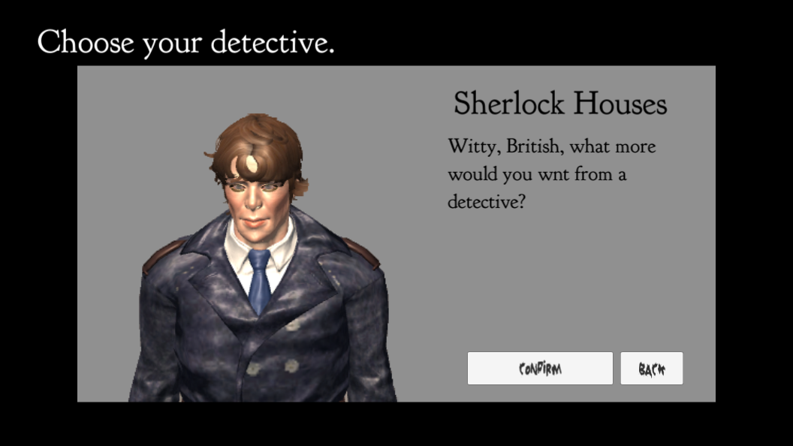

If you wish to play as them, press confirm and the game will begin. Pressing back will take you back to the previous screen, allowing you to choose another detective.

# 

# 

# Gameplay Controls

**1. Notebook Button**

Opens the detective’s notebook

**2. Pause Button**

This button pauses the game and opens the pause overlay

**3. Map Button**

Opens the map overlay

**4. Detective (Player)**

The player model

**5. Clue**

A collectable clue (in this case a chalk outline of a body).

## Detective Controls

The detective is controlled with the Left and Right arrow keys to move them across the screen. Walking off the edge of a screen will take you into the next room if it is possible. As the map is circular, walking constantly in one direction will eventually take you back to the room you are in. Pressing the down arrow will make the detective face the screen.

## Interacting with the world

The mouse cursor will change to a magnifying glass when it hovers over an interactable object in the world. These include doors, furniture and clues. Clicking on a door will take you into that room. (To exit the studio you must click on the exit door). Clicking on a clue will add it to your inventory and display the clue panel overlay. Once a clue is in your inventory, you can review it in the notebook panel.

# The Notebook

The notebook is where you can review all of the information from characters and clues you have gathered so far. The left hand side is where the character information is placed, and the right hand side contains the clue information. 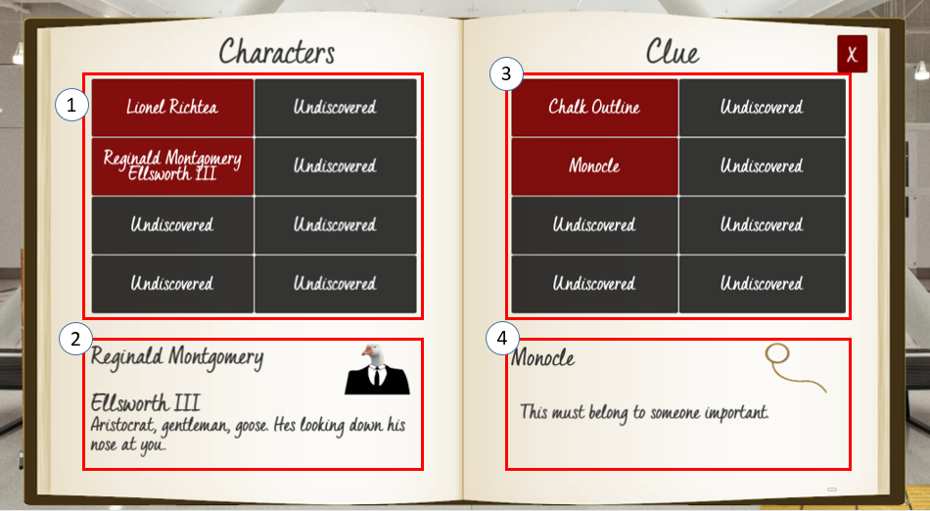

Once you have talked to a character, you will be able to review what you know about the character. Similarly to the clues, but on the left-hand side of the screen, clicking on a button with a character’s name on will display the information you know about them.

**1. Character Buttons**

Clicking on one of those will display information about that character in the character information section below. (see point 2)

**2. Character Information**

After clicking on a character button, the name, image and a description of that character will appear here.

**3. Clue Buttons**

Clicking on one of these buttons will display information about that clue in the section below (see point 4).

**4. Clue Information**

After clicking on a clue button, the name, image and description of that clue will appear here.

# The Map

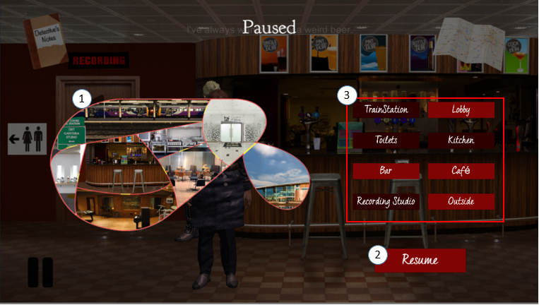

The map can be used to view the layout of the rooms and to also fast travel between rooms that have already visited.

**1. Map**

This shows the layout of the rooms, with the yellow sections on the borders representing a door/path between rooms.

**2. Resume**

This button hides the map menu and minimises a game

**3.Room Buttons**

This section contains the buttons representing each room. If a button is light red, for example the “Lobby” button on the image below, it means the player has visited the room, and by clicking on the button can fast travel to it. If it is dark red, for example the “Toilets” button, the player has not visited this room and cannot fast travel to it.

# 

# 

# Interacting with Characters

Similar to clues, when you hover over a character it will change to a magnifying glass.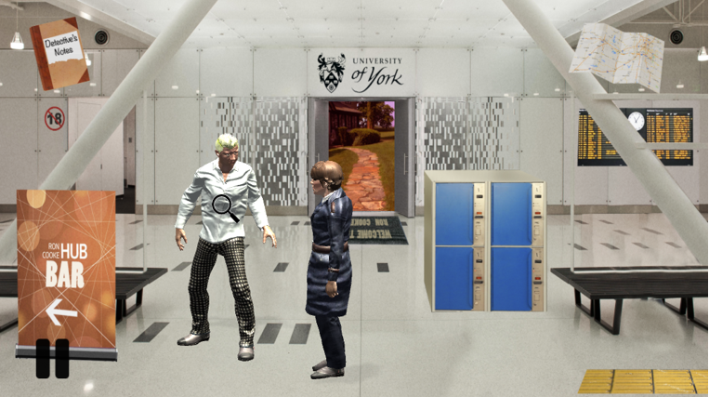

If it’s the first time you have spoken to a character, there will be an introductory sequence of text of the detective asking who they are. Press the continue button to go to the next line. 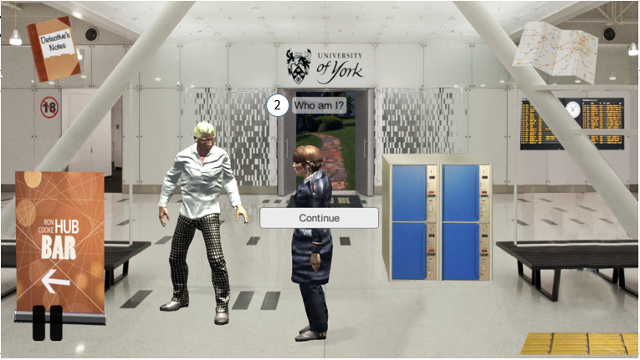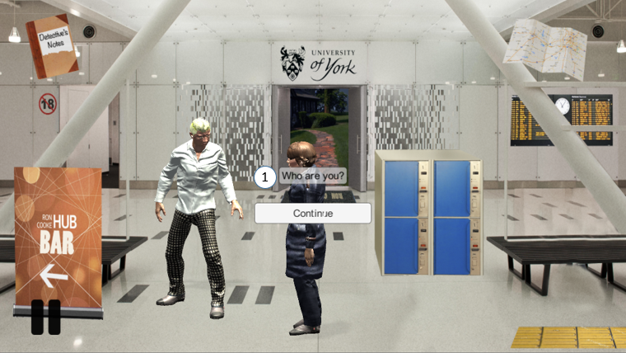

**1. Speech said by the detective**

**2. Speech said by the character**

This format is the same when you ask a question to the character. Pressing continue will show the next stage of the conversation before returning to the speech panel. (See below)

After this introductory text the speech panel will appear : 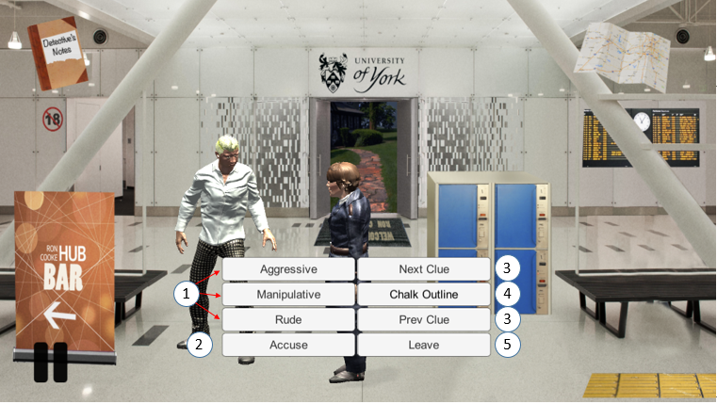

Clicking on a character will open up the speech panel at the bottom of the screen.

**1. Ask Question Buttons:**

These three buttons ask the question in a different manner depending on the traits of the current detective. The text on each button represents the trait to ask the question in.

Once you ask the question, the text is in the same style as the introductory text. Press continue to see the next stage of the conversation. When the character has given you all the information about that clue the speech panel will appear again.

**2. Acuse Button:**

Once you think you have gathered enough evidence to accuse a character of the murder press this button. If you are correct then you have won the game and the , however if you do not have enough evidence or you accuse the wrong person, you cannot accuse them again without further evidence.

**3. Cycle Clue Buttons**

These buttons cycle through the clues in the detective’s inventory. Use them to select which clue you want to question the character about and then use the buttons on the left to ask the question in the specific manner.

**4. Clue Name**

This displays the name of the currently selected clue. The value of this changes using the Cycle Clue Buttons.

**5. Leave**

This exits the conversation with the character.

# Hints and Tips

* **You can’t correctly accuse a character of the murder without the murder weapon and a clue suggesting the motive**
* **Check all of the furniture in a room for a hidden clue**
* **Asking characters about a certain clue can reveal links to the murder**
* **Characters will react differently to each trait, they may sometimes hide information if they don’t like your tone!**



**The WeDunnit Collective**